Dis-AM,S-Peru-Moche-Tumi Stirrup Bottle-200-400 AD/CE

Stirrup Bottle 200-400 AD-CE

**Formal Label: Moche Stirrup Bottle-200-400 AD-CE with Tumi design**

**Accession Number:**

**Date or Time Horizon:** 200-400 AD-CE

**Geographical Area:** Peru

**Cultural Affiliation:** Moche

**Medium:** Ceramic

**Dimensions:**

**Weight:**

**Provenance:**

**Condition:**

**Discussion:**

**References:**

Map:

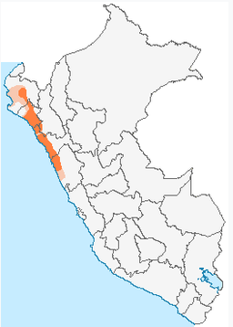

Peru, Moche or Mochica culture

Ceramic, buff clay with brown, red, and cream slip

Moche painted Stirrup Bottle from Peru, ca. 200-400 AD-CE with a cream slip ground and painted in orange, brown, and rare purple/ plum paints. The round body features an orange band at the center with a purple band above having pointed designs, and on the upper body of the vessel is an intertwined undulating band with long effigies with bird heads and long plumed bodies. A very colorful bottle with a rarely found paint color.

**Tumi sacrificial knife**

**Origins**

The origins of the tumi is found in the Moche culture. According to one source, the word ‘tumi’ is derived from the language of the Moche people. Based on oral tradition, the Moche are said to have been navigating along the Chancay River in order to find a suitable place to settle down. Whilst they were travelling along the river, they spotted some sea lions on a shore. They took this as a divine sign, and decided to make their home there. Apparently in their language the word for sea lion was ‘tumi’. As these sea lions were regarded as a sign form the gods, the word ‘tumi’ took on a divine association from then on.

**Order details**

**Sales order**

Sold by [**ancientgas**](http://myworld.ebay.com/ancientgas) ( [992](http://feedback.ebay.com/ws/eBayISAPI.dll?ViewFeedback&userid=ancientgas) )

**Delivery package 1 of 1**

Estimated delivery **Wednesday, Dec 30, 2015** **- Monday, Jan 4, 2016**

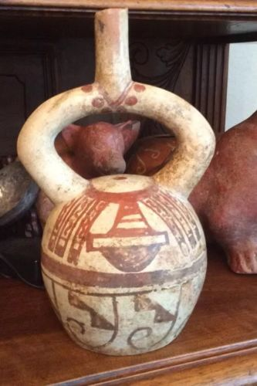

[**Moche IV Blow Bottle 400-600AD Weapon Bundle And Wave + Step Motif**](http://www.ebay.com/itm/221952944734)

|  |  |
| --- | --- |
| Item price | $400.00 |
| Quantity | 1 |
| Item number | 221952944734 |
| Shipping service | USPS Priority Mail Large Flat Rate Box |